ASSIGNMENT 3

Python Programming

|  |  |
| --- | --- |
| Assignment Date | 4 October 2022 |
| Student Name | A.Abitha |
| Student Roll Number | 211519104006 |
| Maximum Marks | 10 Marks |

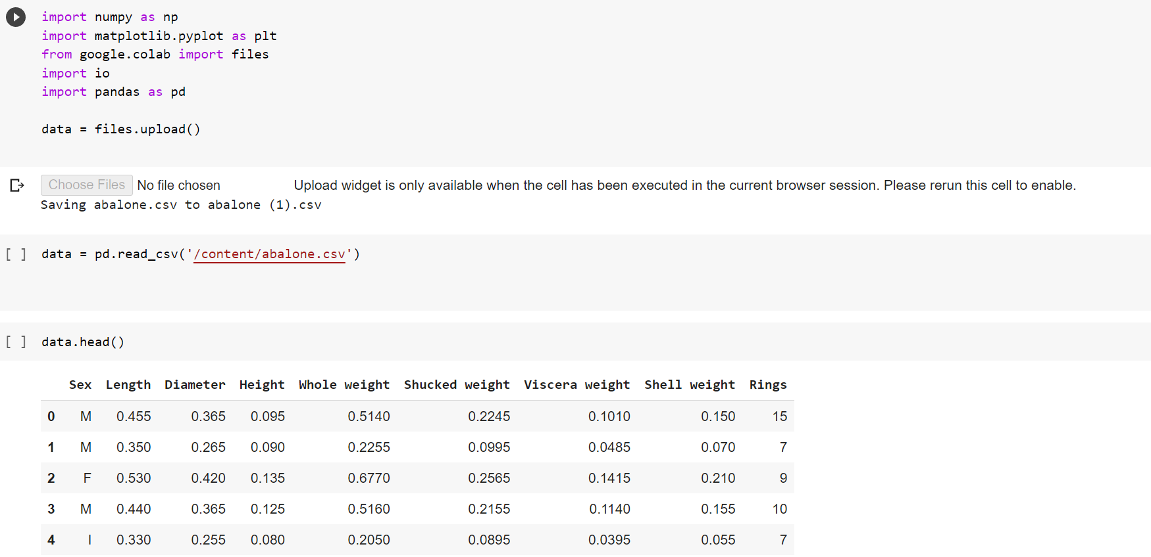

Qn 3:

Perform Below Visualizations.

∙ Univariate Analysis

∙ Bi-Variate Analysis

∙ Multivariate Analysis

Univariate Analysis

import matplotlib.pyplot as plt

import seaborn as sns

data.dtypes

plt.scatter(data.index,data['Height'])

plt.show()

Bi-Variate Analysis

import seaborn as sns

sns.boxplot(x='Sex',y='Height',data=data)

plt.show()

Multi-Variate Analysis

import seaborn as sns

sns.pairplot(data,hue="Rings",height=3)

plt.show()

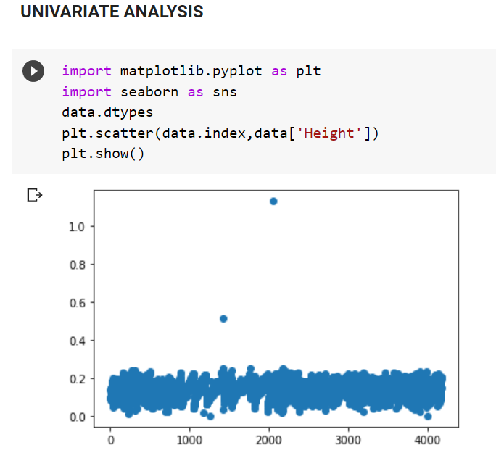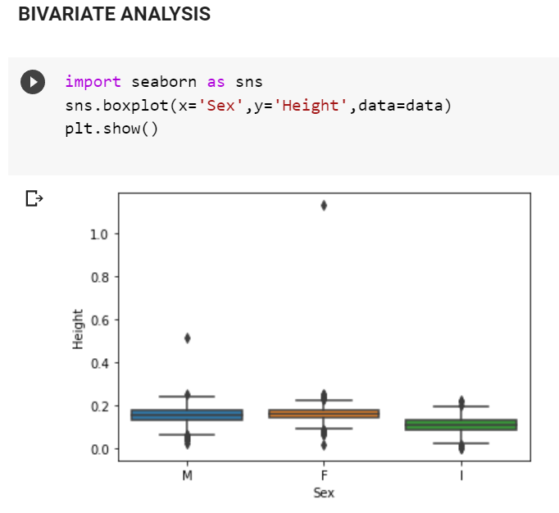

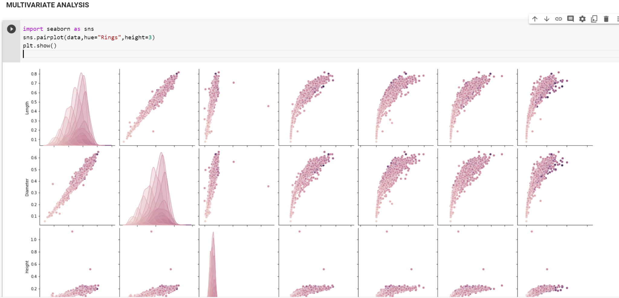

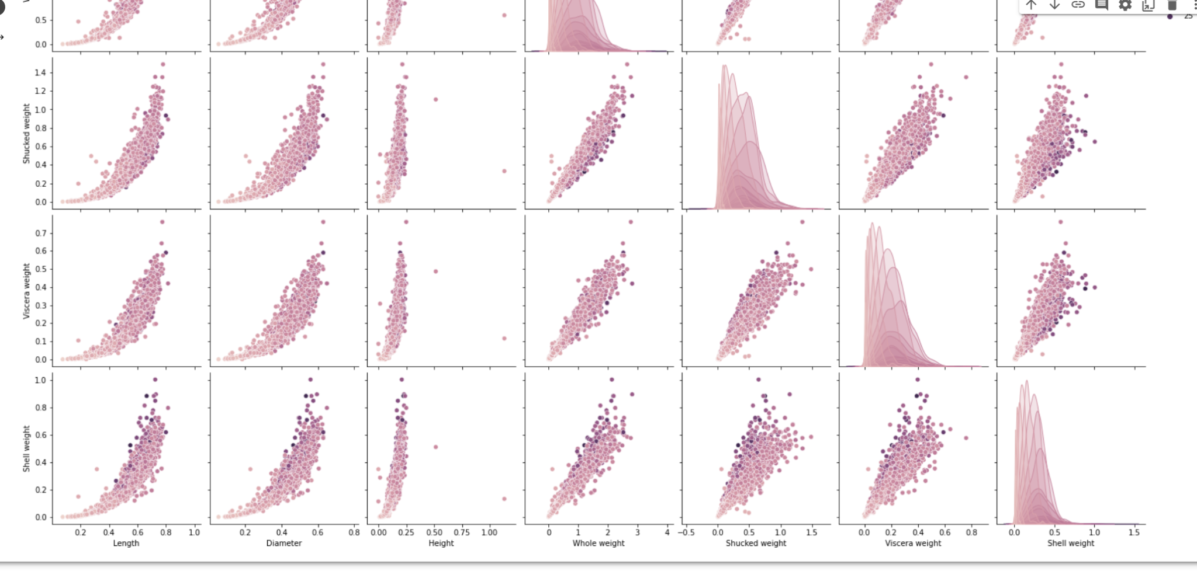

Qn 4. Perform descriptive statistics on the dataset.

import pandas as pd

import numpy as np

df = pd.DataFrame(data)

print (df)

df.describe()

df.count()

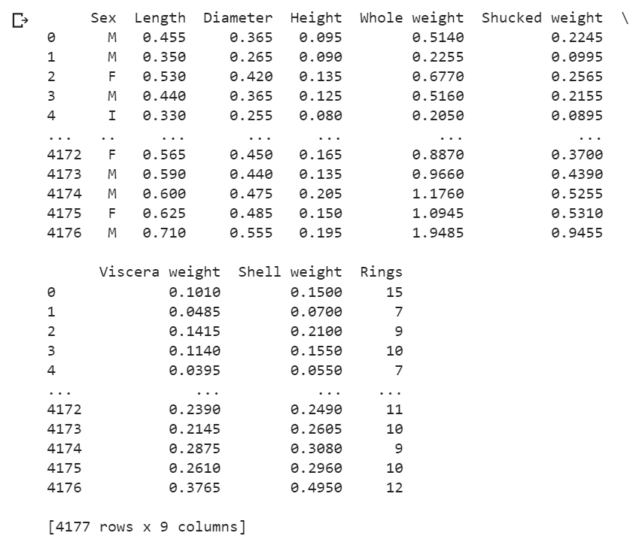

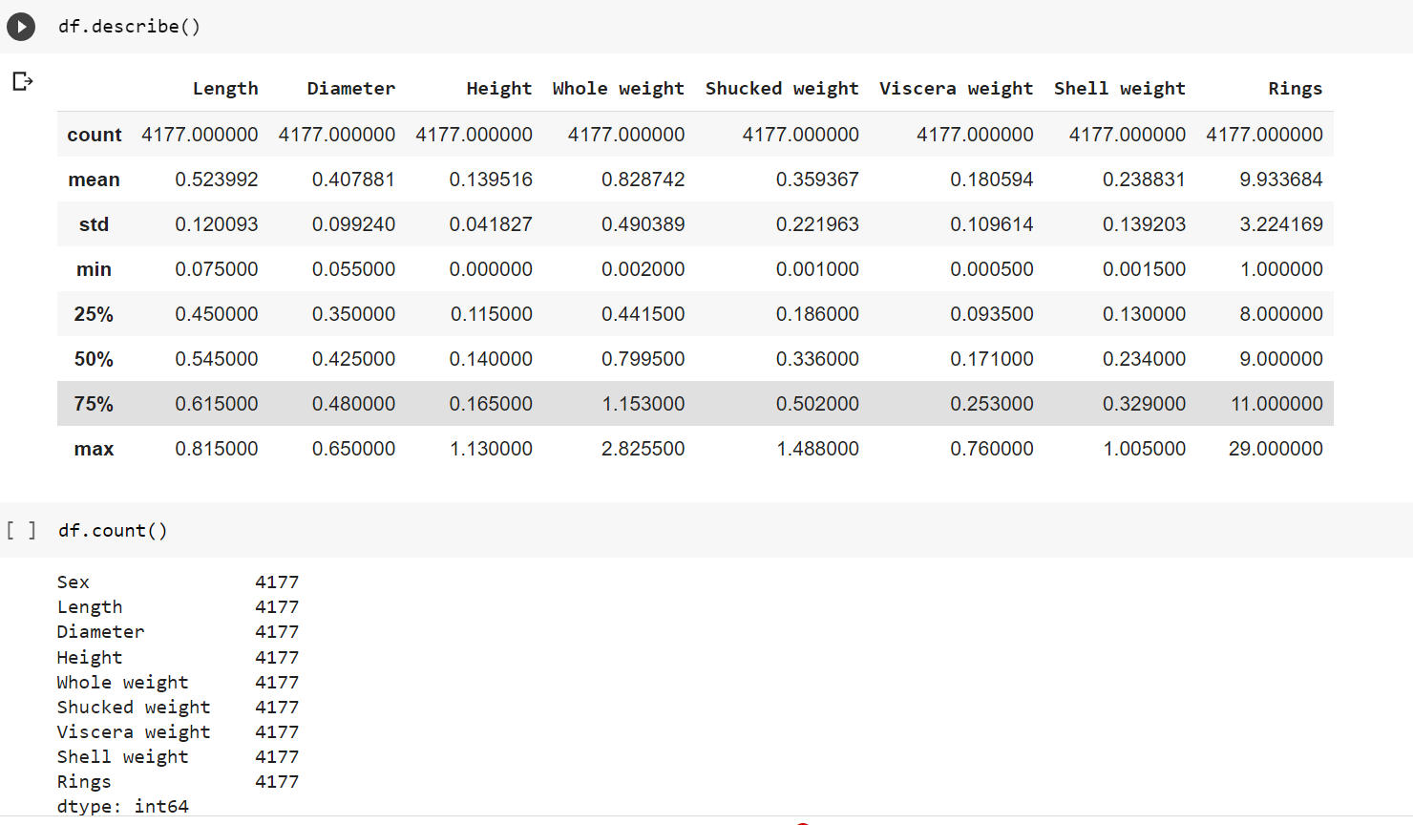

Qn 5. Check for Missing values and deal with them.

df.isnull().sum()

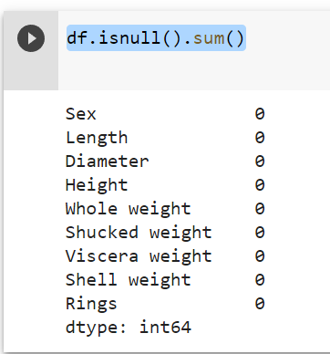

Qn 6 Find the outliers and replace them outliers

import seaborn as sns

sns.boxplot(x='Height', data=data)

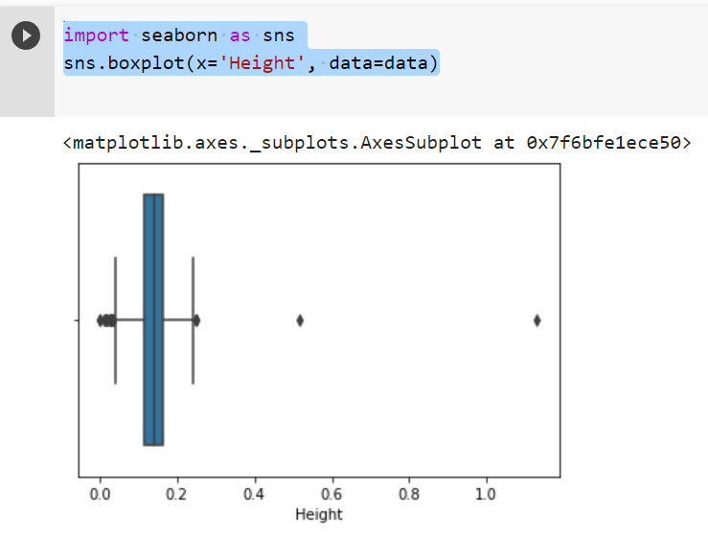

Qn 7. Check for Categorical columns and perform encoding.

df = pd.DataFrame(data)

import pandas as pd

x=df.iloc[:,3:13].values

y=df.iloc[:,13:14].values

x.shape

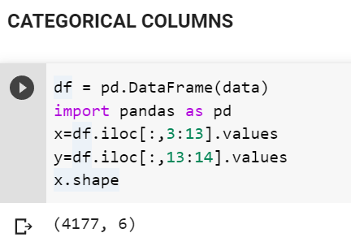

Qn 8 Split the data into dependent and independent variables.

x=df.iloc[:,3:13].values

y=df.iloc[:,13:14].values

x.shape

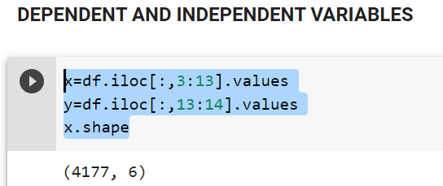

9. Scale the independent variables

X = df.iloc[:, :-1].values

print(X)

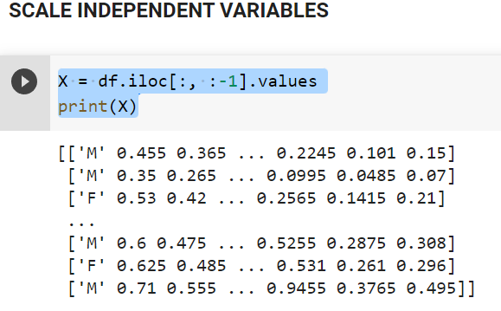

Qn 10. Split the data into training and testing

from sklearn.model_selection import train_test_split

x_train,x_test,y_train,y_test=train_test_split(x,y,test_size=0.2,random_state=0)

x_train.shape

x_test.shape

x_train.shape

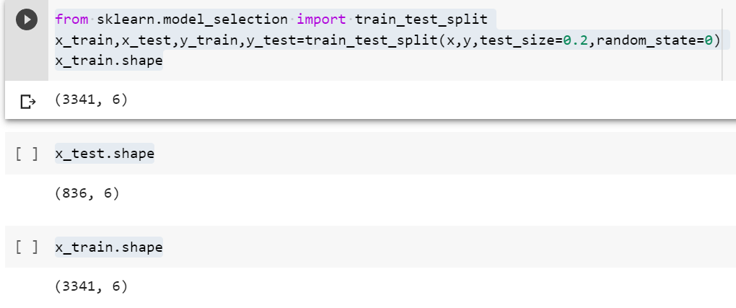

Qn 11. Build the Model

my_dict=pd.read_csv("/content/abalone.csv")

df = pd.DataFrame(my_dict)

print(df)

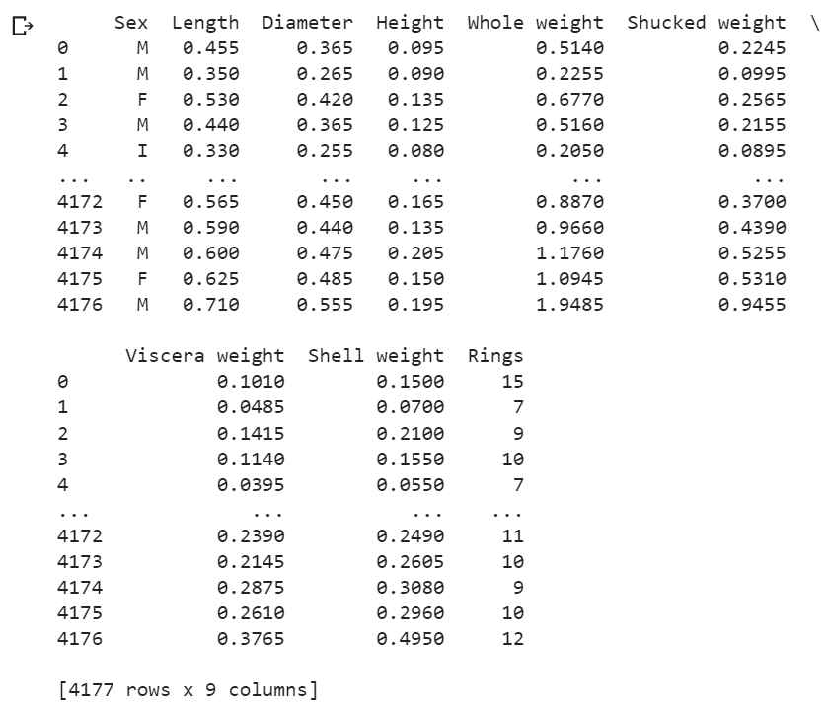

import csv

with open ("/content/abalone.csv") as csv_file:

csv_reader = csv.reader(csv_file)

df = pd.DataFrame([csv_reader], index = None)

for val in list(df[1]):

print(val)

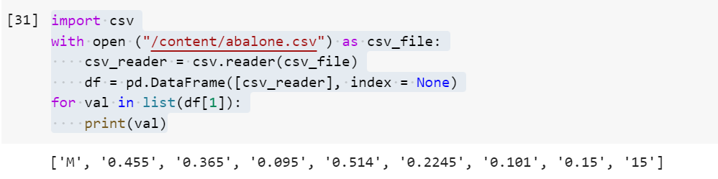

Qn 12 & 13 Train and Test the Model

from sklearn.model_selection import train_test_split

train, test = train_test_split(df, test_size=0.2)

print(train)

print(test)

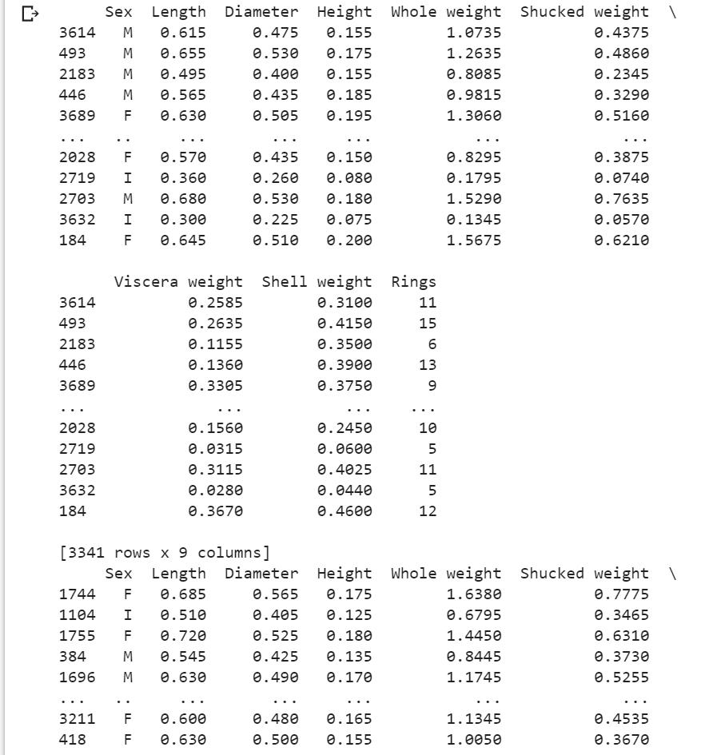

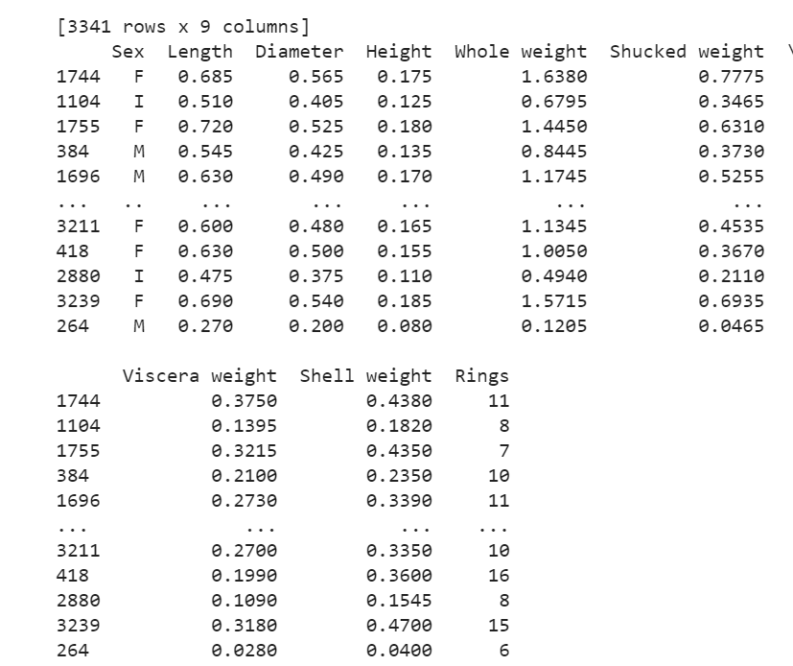

Qn 14. Measure the performance using Metrics.

pd.crosstab(Y_test,y_predict)

print(classification_report(Y_test,y_predict))